History of Asakusa 1

1:The beginning
６２８(1392 years ago)When two brothers of fishermen were fishing in the current Sumida River, it was not the fish but the doll of God that caught the net. At the time, when they talked to a well-educated celebrity in the area,he was told that it was a merciful god who practiced hard and saved people.
This god transforms into various forms to save people from various sufferings and hesitations, and is generally known by the name of “Kannon-sama”.
This Kannon-sama is now enshrined in Senso-ji(temple). In addition,three people who found this god are dedicated to the current Asakusa-jinnja(shine)
as local gods, and the origin of the current Sanja-matsuri(festival) is here.
2：As a sacred place. It prospered as a large temple in the current Kanto region, and since the time of the Samurai, many samurai have visited as a temple to pray for victory, and it is proteceted by the kings of each era.
3：As a place of popular culture.
Since the Edo period(about 400 years ago), Asakusa has prospered as city of the common people. In the early Edo period, it received protection as a prayer place for the Tokugawa-ke(king), and and eventually developed into a city that was loved by the general public.
Eating and drinking, performing arts, geisha, amusement park …, I think the original form of Asakusa today was made during this period. From the Edo middle of the Edo period, Asakusa-okuyama(adress) prospered with spectacle huts and street performances, and became a typical downtown area of the Edo period. Also, after Kabuki “Edo Sanza (3 playhouse)” became Asakusa-sarugaucho(adress) in the late Edo period, it will become a famous place all over Japan.
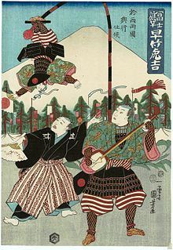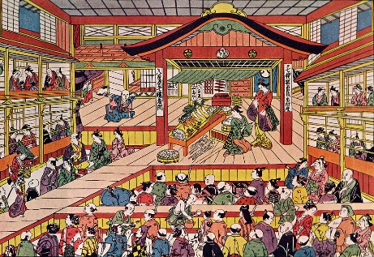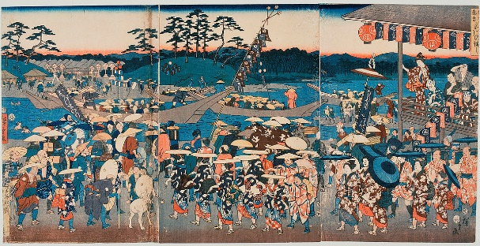

Amakaraenisi
Koji Obana

