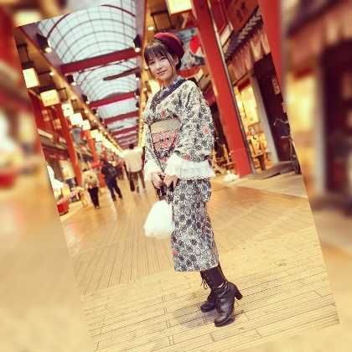
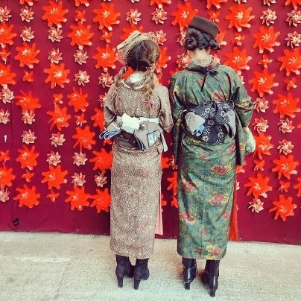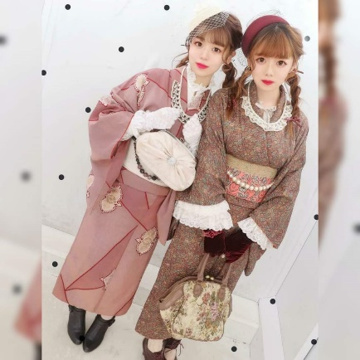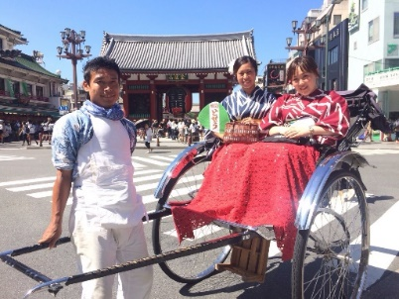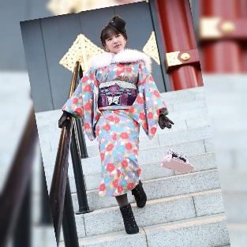
Retro modern fashionable
Do you know that Asakusa is a treasure trove of retro café ? and famous shops.
Wear a retro-modern kimono, ride a Jinrikisha, go around a retro café shop, take a commemorative photo at the place you discovered, and take a time trip to Tasho Romance(Japan old time, 1912～1926)

1：Wearing retro modern kimono(Western clothes and Japanese kimono design mix)
2：Take a ride on a Jinrikisha and learn about the features of successive cultures and the characteristics of each café shop.
3：Take a map and visit interesting café shop.

Amakaraenisi
Koji Obana

