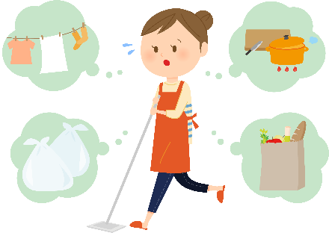
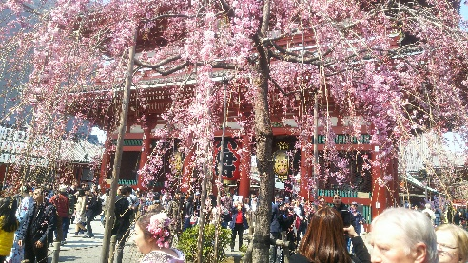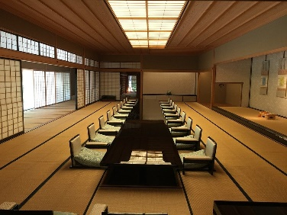

Long distance from business, life from short distance
I think wisdom and ingenuity will be important after corona.
I think that long-distance travel will gradually recover from business from need. However isn`t it dull in conversation while masking at the office and keeping a distance from people ? While taking safety into account, it may be possible to refresh your mood and produce good results by taking advantage of the long-established stores in Asakusa or taking a gentle walk during meeting.
It is also a good idea to think about ways to enjoy teleworking and working from home that can change the environment and family.
I think that the enjoyment in life will gradually spread from near home. I think it will be an opportunity to rediscover and dig into various things, and increase new fun.
Asakusa is a place where you can propose various fun.

Amakaraenisi
Koji Obana

