Beginning of summer, midsummer, end of summer
When do you feel romantic ?

- The Asakusa Sanja Matsuri is an event that announces
the beginning of summer.
This year from the evening of May 17.
- The Sumida River Fireworks Festival is a midsummer event.
July 27 this year.
- And at the end of summer, authentic New Orleans Jazz,
last week of August, Samba Carnival, last week of August Saturday.

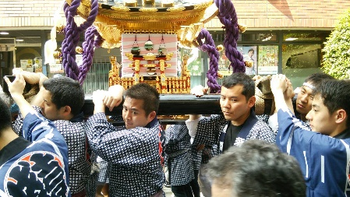
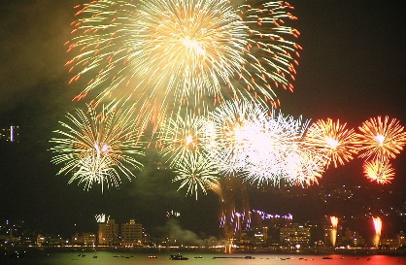
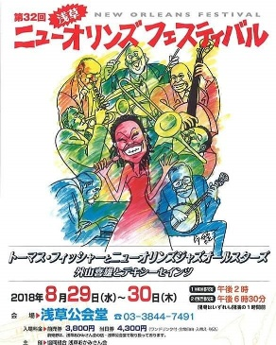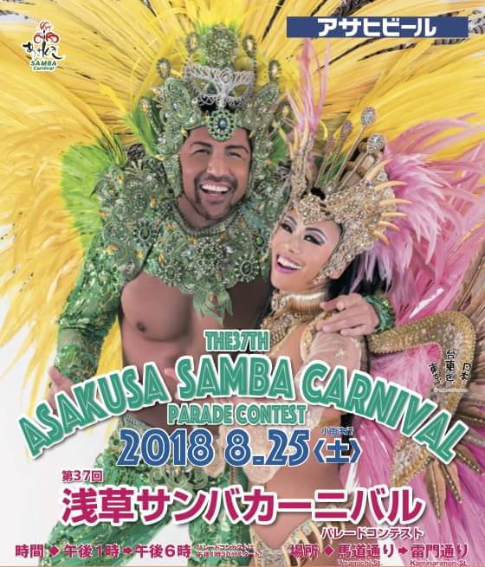
Amakaraenisi
Koji Obana

