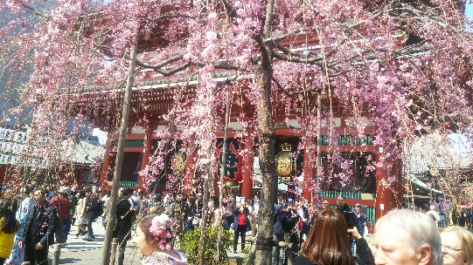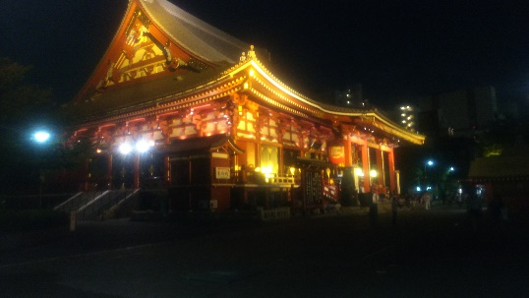
,

Promotional help Ⅱ

Asakusa has a rich history, and there are many historical cultures that are unknown to
the general public.
Therefore, I will provide information that can explain such history and culture(and view point etc…), or what kind of celebrities are currently coming, what kind of people such as local people, foreigners Japanese,etc.

Amakaraenisi
Koji Obana

