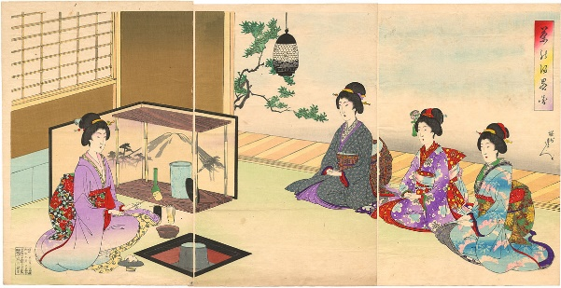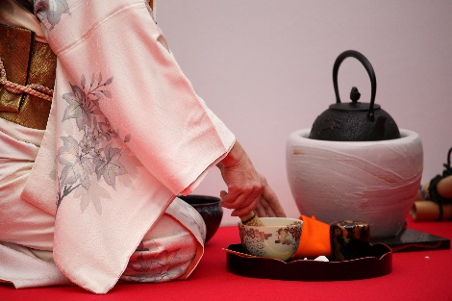
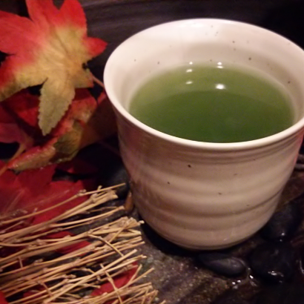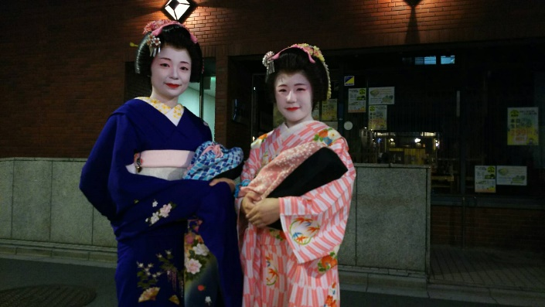

Asakusa tea and tea and tea

There are many ways to enjoy Japanese tea. Asakusa with various tastes and styles.

- Enjoy Japanese tea in the authentic tea ceremony that Furisode-san put.(Above picture)
- After taking a walk with Asakusa with Furisode-san,enjoy Amakaraenisi recommended popular brown rice tea or roasted tea with Japanese sweets.
- After taking a walk around Asakusa freely, enjoy Japanese tea at each restaurant that boasts a good meal and delicious food.。

Amakaraenisi
Koji Obana

