Asakusa night view from the open-air bath

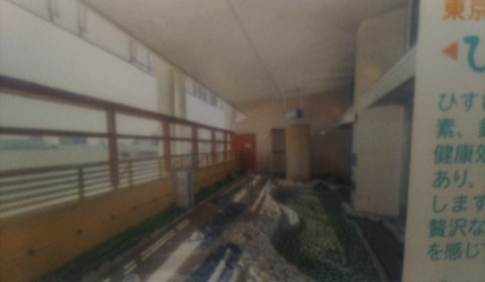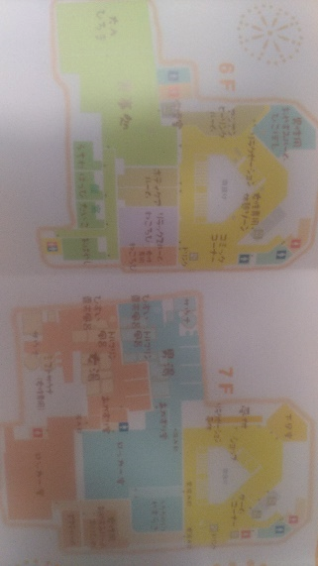
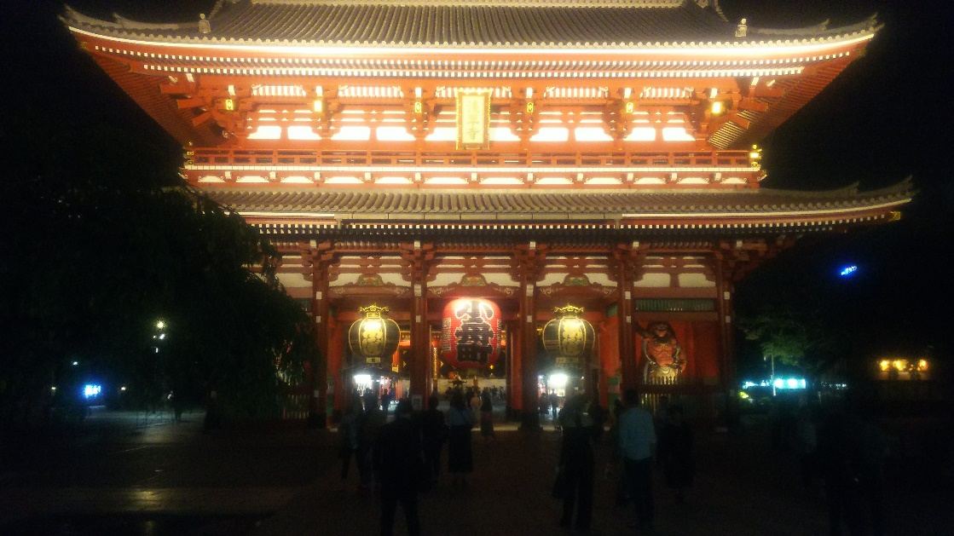
- A long-established meal.
- Asakusa night view from the open-air bath.
＆Asakusa entertainer entertainment.
- The next day, Asakusa artist and Asakusa walk.

