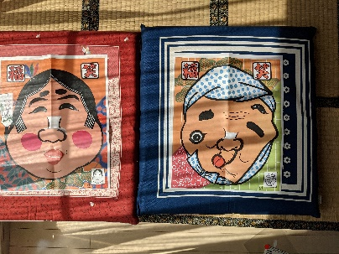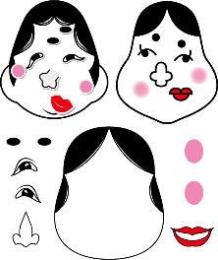
Old play① Fukuwarai Fortune comes when you laugh
Fukuwarai is a play that you can enjoy by blindfolding and combining a picture of face with nothing written on it with a picture of eyes,nose,and mouth. The model man is Hyottoko, the woman is Okame, and the originally charming face changes in various ways.
You are looking forward to cutting the eyes, nose,and mouth of paper with scissors in advance.
You will feel the freshness of this kindof play while traveling in Asakusa.

Amakaraenisi
Koji Obana

