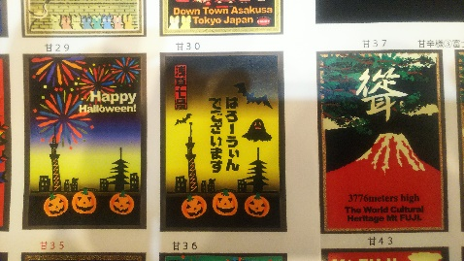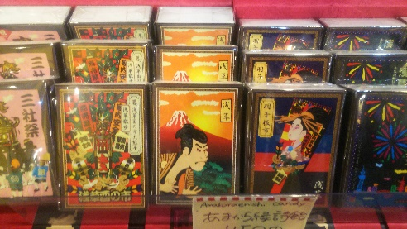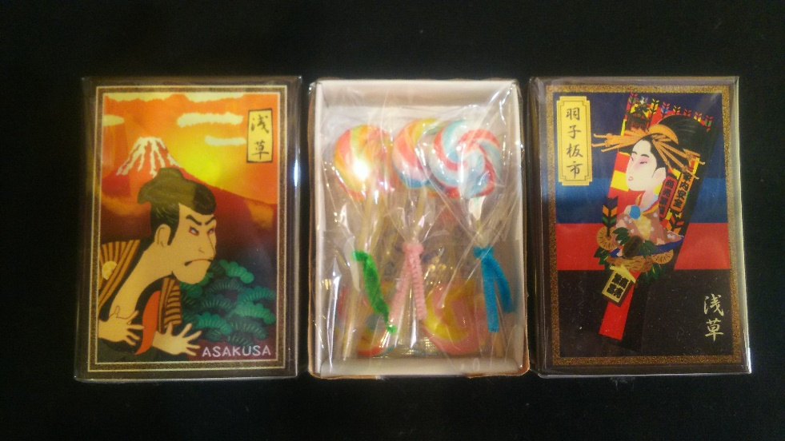
Cute Asakusa souvenir

The size is a little smaller than cigarettes, and it contains cute and delicious lollipops. You can choose from a variety of designs, such as those based on the Asakusa festival, Kabuki, and Mt Fuji. All of them are tasteful designs written by craftsmen snd will surely please those who have met. Anyone who has this will say that eating is so cute that it is a waste.
Write a simple message, name or company name if there are more than 20.

※The new spring Asakusa Kabuki, which is said to be a young dragon gate,isnow open for visits.（2020.1.2～1.26）
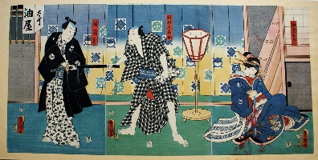
www.asakusakabuki.com

Amakaraenisi
Koji Obana

