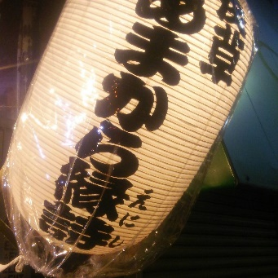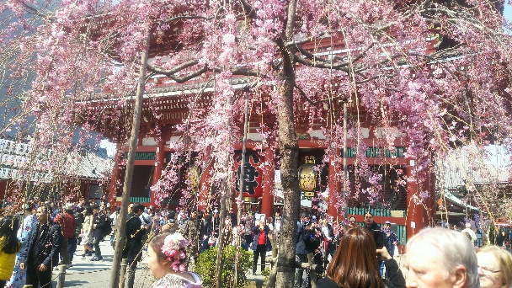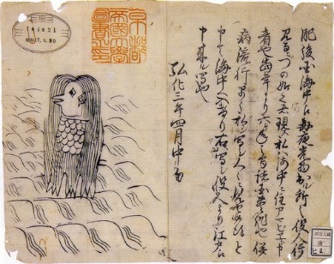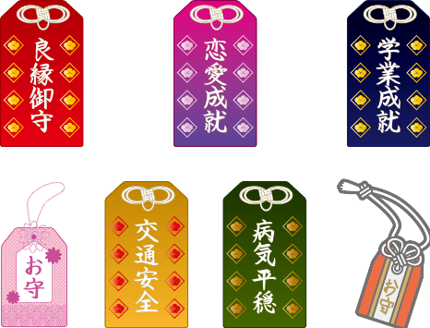
Virus removal power spot(Corona measures)
There are many temples and shrines around Asakusa, and various benefits and origins have been passed down to the present day.
This time about Virus removal power spot.
In Atsuta shrine,a aword called “Inyomaru”,the largest in the north of the Kanto region(total length 368.5cm), is preserved, and when the cholera virus became widespread in the latter half of the Edo period, “Inyomaru”was circulated throughout the city as an event to remove the zirus. Will be done.。
It is displayed in front of the shrine building every year in the first week of June.
Fuji shrine is a shrine that started from Mt Fuji faith, now it is famous for the number of days of the Saturdays and days at the end of May and the last day of June,4days,it seems that it was an event with the mountain opening. ,
,but this period It is distributed to the number of “Mugiwaraja” as a result of virus and water raw raw in 3 days.
Also,in Japan,there is a half-man, half-fish apparition that predicts a good harvest and virus called “Amabie”, and is beneficial for the spread of virus. It became a boom in the Edo and Meiji eras, and has recently become a hot topic again.(picture on this page)
I wish you health and happiness.
Amakaraenisi
Koji Obana

