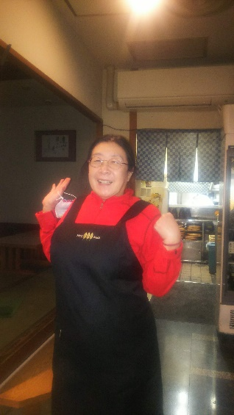

Asakusa Meister who immigrated from overseas ②

Ms Leslie , a talented woman from Hawaii who was studying Japan at the University of Hawaii. After visiting Japan, She lived in Asakusa for long time ,and now she is also active as the general manager of sales at Asakusa New Year Kabuki and events, and she have earned the deep trust of long-established stores and famous store owners in Asakusa.
Asakusa as seen from her should be a little different. How about her guidance for a fun tour of Asakusa.
Also active as an English conversation teacher and hula dancer.

Amakaraenisi
Koji Obana

