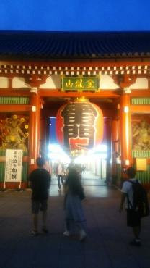
※You Tube 振袖ガールズ 上を向いて歩こう or furisodegirls ueomuitearukou
You can see it on You Tube

Promotional help

I will assist you in suggesting photos and videos to invite customers, acquaintances and friends.
I would be grateful if you could tell me what kind of image you want in the picture, the desired scene and angle,and the video.
Not only me, I will work with my friends and acquaintances in Asakusa to help.
In Asakusa, I think that the symbol image of Kaminari-gateetc.is strong, but together with that, I will help you to grasp the image of fun and experience.

Amakaraenisi
Koji Obana

