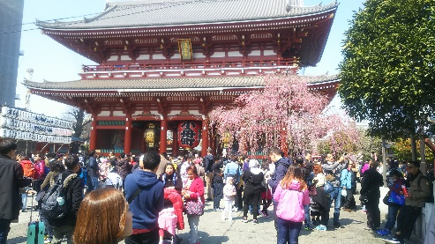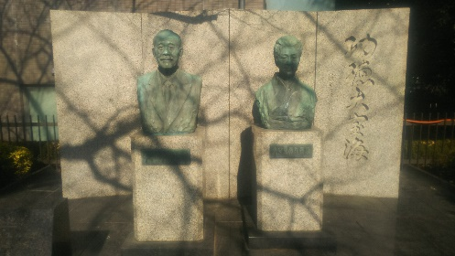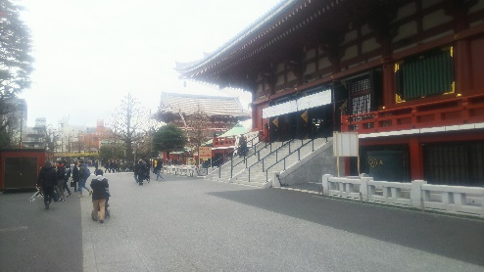
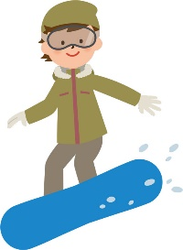

Snow play from Asakusa

Mr Yonetaro Otani, founder of New Otani, one of leading hotels in modern Japan, was born in Sumo wrestlers who has made great business and social contributions.
He donated the Hozomon in front of the current Sensoji Tnmple and contributed to Asakusa, so his stone statue was erected behind Sensoji Temple, and his company is still connected to Asakusa.
By the way, there is a ski resort NASPA in Yuzawa,Niigata Prefecture, where you canenjoy the hot springs managed by the New Otani Group, and it is one and a half hours away by Sinkansen-train to Tokyo.
In the winter season, how about planning while enjoying winter sports in Yuzawa withsnow and then playing in Asakusa without snow ?

Amakaraenisi
Koji Obana

